Week 2 Data Collection Cleaning and Preprocessing

1. Project Definition
Week 2 focuses on trust—more accurately, on the extent to which you need to place your faith in logistics data if you really want your projects to be successful. I have been using the DataCo Smart Supply Chain dataset, which is essentially a treasure trove for those who want to test out new supply chain ideas. My approach is to work through the dataset step by step, beginning with collecting the data, then checking it, cleaning it, and getting everything ready with the help of Python. If you're interested, you can carry out exactly what I'm doing—just start with the original CSV file, use the same code, and follow the same steps. I'm not hiding anything; data cleaning is always full of surprises, and I'll clearly point out the moments when things become interesting.
Before turning to the code, let's first consider the main points. This week my main objective is to get the DataCo dataset ready for use—which means locating any errors, filling in the missing entries and preparing the key features all while ensuring that we don't distort the message that the data actually wants to convey. The difference becomes significant afterwards since it then becomes possible to start measuring deliveries or building models without having to worry about any underlying problems. One thing to bear in mind is that the dataset has 180,519 rows, but that doesn't mean that there are 180,519 shipments. There are instances where several rows are linked to the same order if that order consists of more than one item. Hence, my first step is to determine precisely what each row represents. I always check the unique IDs to avoid any duplication or accidental repeats.

2. Data Collection Simulation
Certainly, go ahead and copy my steps as closely as you wish, but just make one promise me: do not modify the original file. When you are working, always use a copy. Keep a record of all your actions and store your cleaned version in a safe place. In no situation should you overwrite your raw source.
Starting is very easy: you should download the DataCo CSV file (along with the notes) from Kaggle and place it into a folder that you’ll be able to remember, also making a note of both the location and the time at which you obtained it. For now, put the clickstream data aside and always use a clean, unaltered version of the data—should you ever need to run a procedure again or explain your method at a later stage, you’ll appreciate having done this.

3. Data Quality Checks and Cleaning Plan
By all means, whenever you come across something odd, don't just go around fixing it immediately. Instead, first record any unusual features: for instance, missing values, duplicate IDs, odd delivery times, big empty gaps—any aspect that appears wrong. Rather than simply deleting columns or rows right away, take the time to look at the issues beforehand. If the 'delay' field is blank for some orders, exclude those orders when you're looking at delays and keep a note of how many rows you're omitting. In the case of missing numbers, I use the median because it is less influenced by odd outliers. When 'Shipping Mode' is missing, regard it as 'Unknown'. There's no need to create up values. And if you have to impute the missing data for use in later modelling, do this only with the training set—not on the entire dataset at once.
It is worth taking note of outliers. It isn't true that extreme values are always errors—there might have been a valid explanation for why a shipment actually took much longer than expected. Use the IQR method to spot any values that appear unusual, but only remove those rows if you are sure that they are wrong. There are cases in which keeping the odd entries helps you to identify genuine business problems.

4. Preprocessing Methods Applied
So, here’s what my process looks like in practice:
- Check the schema and data types: Make certain that all the columns actually correspond to those in the data dictionary, confirm that the numbers are in fact of a numeric type, and ensure that the dates are not just odd strings.
- For the missing values, calculate how many there are and where they are; when preparing for modelling, delete all the rows which have missing values in the outcome column and fill in the rest by using 'Unknown' for categories.
- As for duplicates and invalid rows: get rid of the exact duplicates. When you encounter identical item-level IDs, flag them for review and don't just delete them at once.
- When you are carrying out outlier checks, use the IQR to spot any values that appear to be abnormal, but do not simply remove them since in some cases the outliers do represent genuine signals.
- Scale and encode: If a column has outliers, use RobustScaler. One-hot encode items such as 'Shipping Mode'. Do not scale the IDs or the target variable.
- Ensure that there is no leakage by dividing your data according to date and by fitting the scalers and imputers only to the training set before using them on the validation set.

Issue or step | Approach described in the text
Missing numeric values | Use the median; fit model imputers only on training data
Missing categories | Use “Unknown” for missing categories
Duplicates and invalid values | Remove exact duplicates; flag repeated item IDs; coerce invalid numeric values to missing
Outliers | Use the IQR rule to flag; remove only when confirmed erroneous
Scaling and encoding | RobustScaler for numeric features; one-hot encode Shipping Mode
Validation split | Split by date and fit preprocessing on training data only

A quick tip is this: even though RobustScaler bases its procedure on the median and the interquartile range, outliers have no effect on your features, whereas MinMaxScaler tries to compress all the values into a 0 to 1 range and consequently a few large outliers cause the other values to be squeezed into a narrow band. You should therefore select the suitable scaler for your data.

5. Python Code Illustration
Here’s how that all looks in code:

Here is the code screenshot
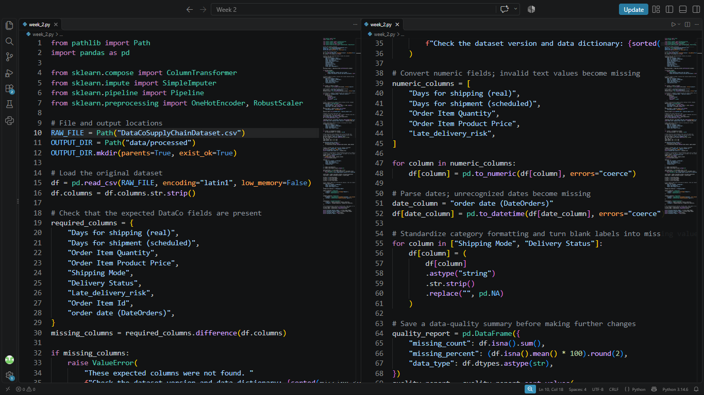
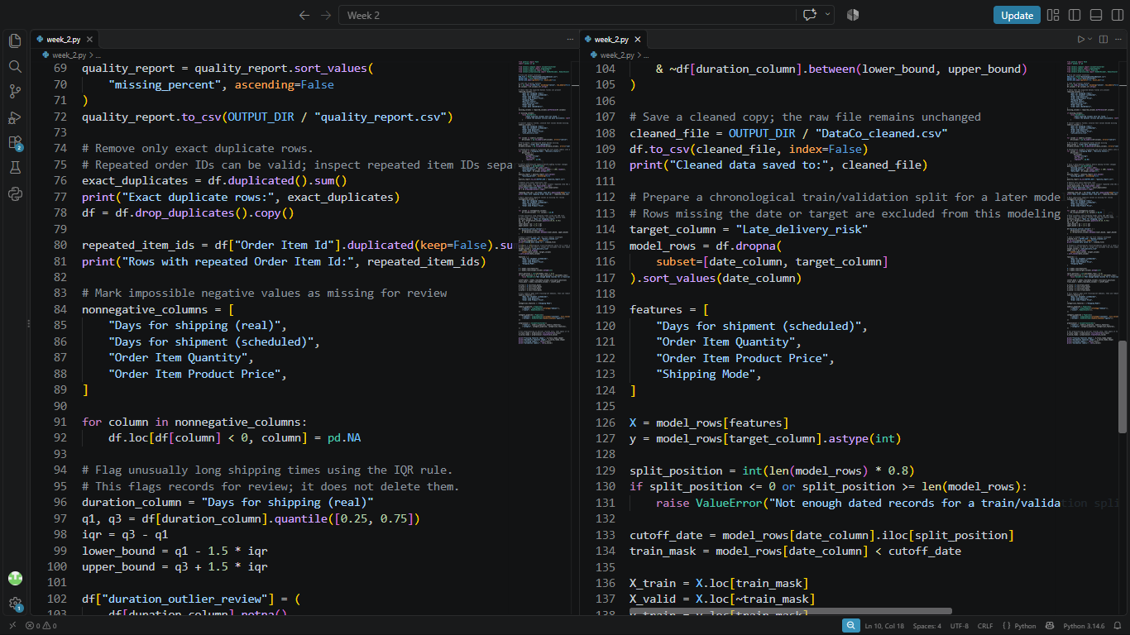
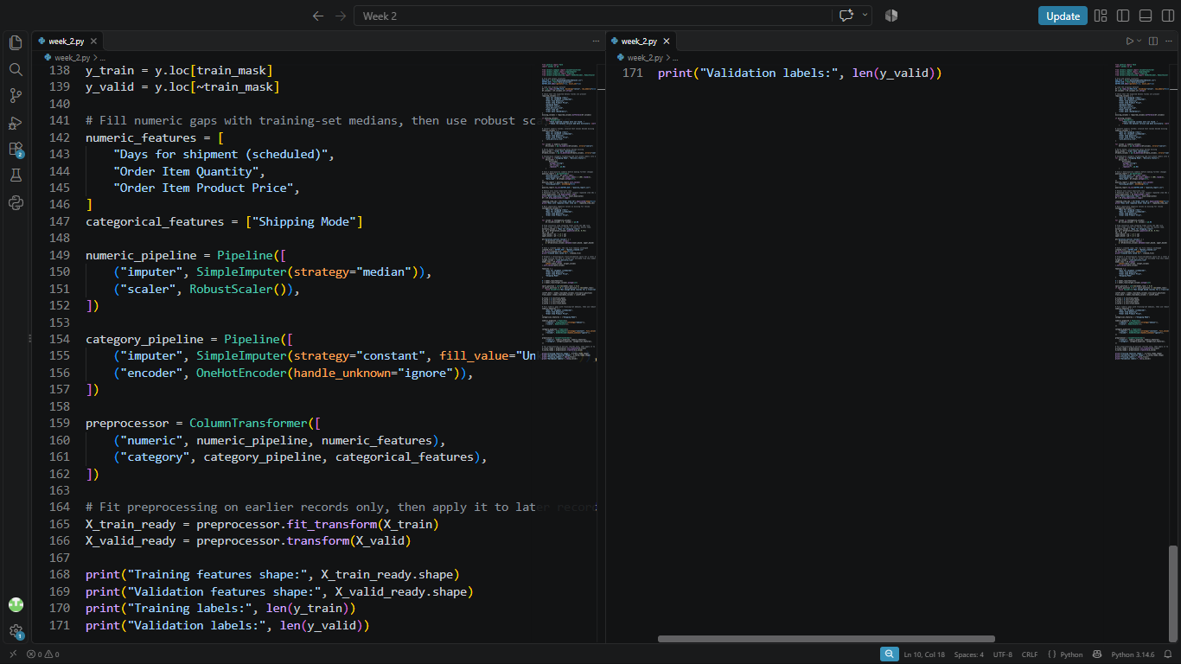

Confining your transformations to the training set makes your validation honest and stops you from "cheating" by letting information from the future leak in.

6. How It Went
The script functioned smoothly, with no duplicate rows or duplicate item IDs. I saved the cleaned CSV file and all seven features made it through the pipeline without any issues. I obtained 144,412 rows for training and 36,107 for validation, totaling the original number of 180,519. Hence, everything is in order and is ready for modeling.
Here is the output table:
Check | Result
Eligible records | 180,519
Exact duplicate rows | 0
Rows with repeated Order Item Id | 0
Training records | 144,412
Validation records | 36,107
Features passed through preprocessing | 7

And here is the Output Screenshot:

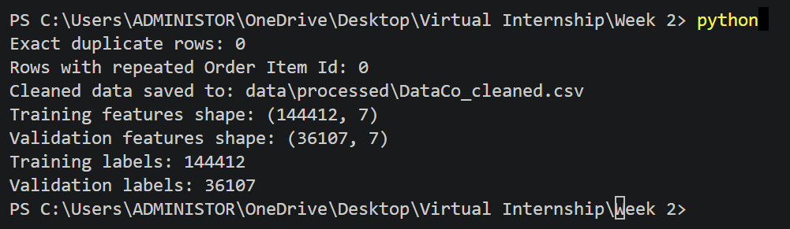

7. Final Thoughts
If the care taken while preparing data is not solid, none of the later steps can fully protect the project. Ignoring missing values or deleting rows without checking them can affect the results. Counting order-item records as separate shipments can also give a misleading picture. This week is about building a process that can be checked and repeated: collect the data, understand what each row represents, identify quality problems, and deal with them carefully. The aim is to make the dataset ready for further analysis while keeping a clear record of what was changed and why. Since the file contains order-item records, its results should be interpreted at the record level unless the data is grouped into unique shipments. This gives the next stage of logistics analysis a more reliable starting point.

